In this session, I am recreating the scd lecture step to step to understand it more deeply. This covers day2 of dimensional data modelling.

A slowly changing dimension can be modelled in different ways, but we are choosing the best way, SCD type 2 which maintains the history of the dimension from start to finish and hence, idempotent.

Recap from the first session, we created Prithvi.nba_players, a cumulative table.

SELECT player_name,seasons,is_active,current_season FROM prithvi.nba_players

order by player_name, current_season

LIMIT 50

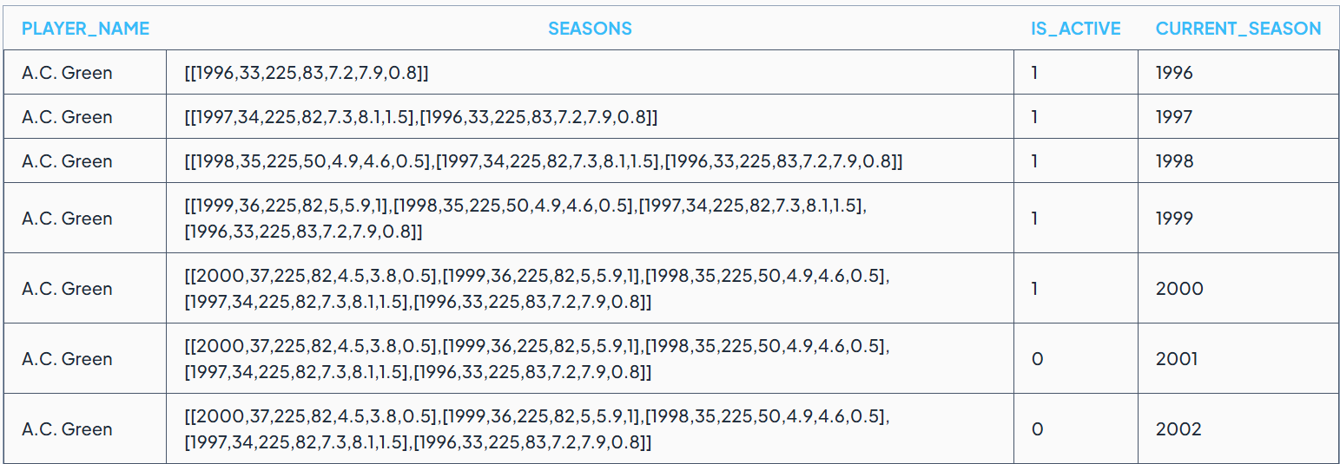

If you look at a sample entry for ac green, seasons, is_active are the changing columns. We would like to understand for a particular player, how his dimensions are changing with time, here season.

Seasons column changes every season, changes very often and could be modelled using yearly snapshot. It does not fit the criteria for how often the dimension is changing. It should be slowly changing.

Now, is_active column for A.C.Green is changing only twice for his entire history of his time as a player. It fits the bill for scd, so, we chose is_active to scd.

The final result should have 2 rows for A.C. Green, with 1 row’s is_active column set to 1 and another row’s set to 0. We would need two additional columns: start_season and end_season to track the starting and ending point for is_active column. These two columns help maintain the entire history.

We will start with creating a schema for implementing this scd.

Schema:

CREATE TABLE prithvi.nba_player_scd (

player_name VARCHAR,

is_active INTEGER,

start_season INTEGER,

end_season INTEGER,

current_season INTEGER

)

WITH (

format ='PARQUET',

partitioning = ARRAY['current_season']

)

Player_name – the dimension which is changing over time

Is_active – the column which changes slowly over time

Start_season- the column which maintains the starting season when the is_active is set to current value

End_season- the column which maintains the ending season when the is_active is set to current_value. The is_active flag changes next season.

Current_season- the variable which tracks the time as season rolls on.

SCD can be implemented either in 1 load query or incrementally. Lets do the 1 load query first.

1 load Thought process:

First, lets see whether if the player was active last season or not. We use lag function to add an additional column is_active_last_season. If there is a change we now know that its changed from its previous season. This is of utmost importance for implementing this scd on is_active column.

SELECT player_name,

is_active,

COALESCE(LAG(is_active,1) OVER(PARTITION BY player_name ORDER BY current_season),0) as is_active_last_season,

current_season

FROM prithvi.nba_players

The coalesce statement handles the nulls for the very first season.

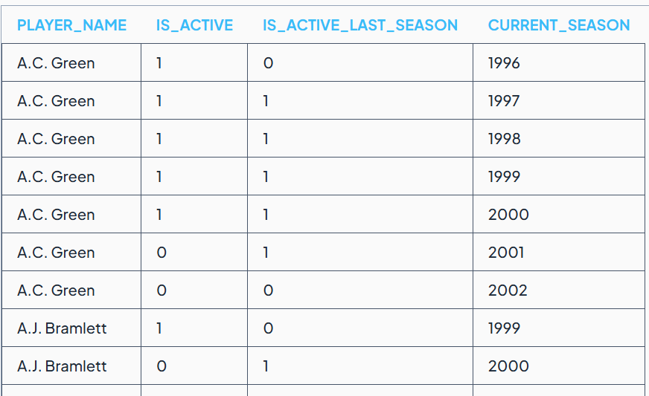

Add a new column called did_change to track the difference between the present and previous season.

WITH lagged AS(

SELECT player_name,

is_active,

COALESCE(LAG(is_active,1) OVER(PARTITION BY player_name ORDER BY current_season),0) as is_active_last_season,

current_season

FROM prithvi.nba_players

)

SELECT *,

CASE WHEN

is_active <> is_active_last_season THEN 1 ELSE 0 END AS did_change

FROM lagged limit 50

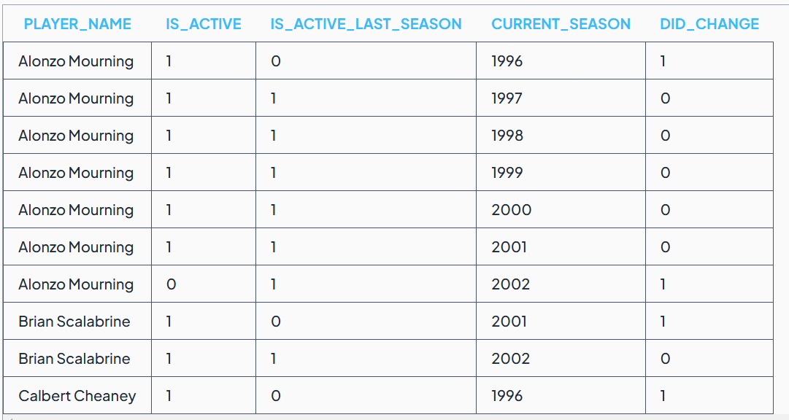

We now count the lifetime ‘did_change’ for a particular player. We can do this by running sum over the did_change column as follows:

WITH lagged AS(

SELECT player_name,

is_active,

COALESCE(LAG(is_active,1) OVER(PARTITION BY player_name ORDER BY current_season),0) as is_active_last_season,

current_season

FROM prithvi.nba_players

)

SELECT *,

SUM(CASE WHEN

is_active <> is_active_last_season THEN 1 ELSE 0 END) OVER(PARTITION BY player_name ORDER BY current_season)AS streak_identifier

FROM lagged

ORDER BY player_name desc,current_season

limit 100

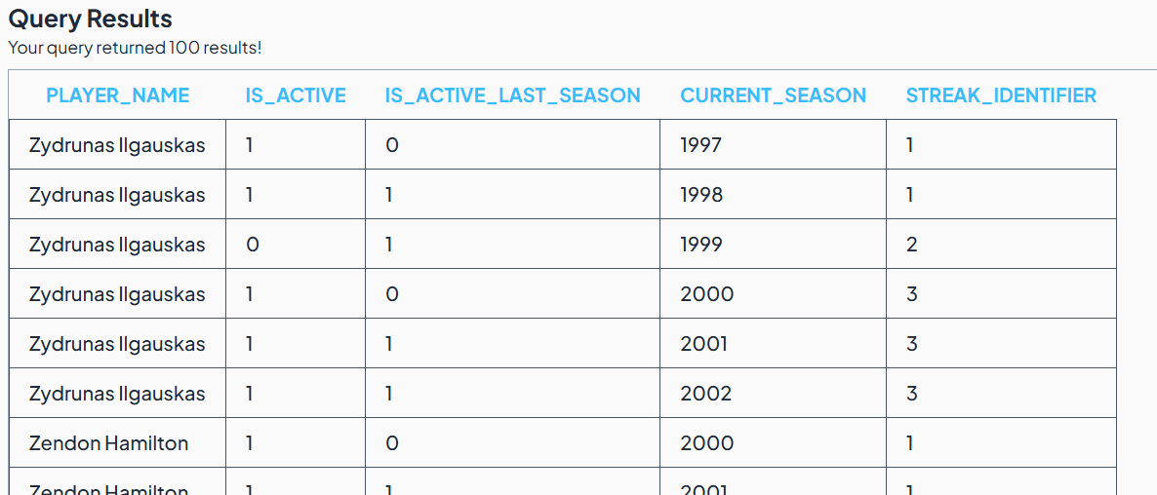

The streak_identifier column now accurately depicts the players behaviour vs time. If there’s a change it increments, if not, it stay the same.

The pair of values: (player_name,streak_identifier) are unique for each streak. In the above example:

* Zydrunas IIgauskas + 1 (streak_identifier) indicates his streak of playing for the seasons of 1997-1998
* Zydrunas IIgauskas + 2 (streak_identifier) indicates his inactive strek for year 1999
* Zydrunas IIgauskas + 3 (streak_identifier) indicates his active streak from 2000 to 2002

We can write a query using group by player_name,streak_identifier to get the final scd table

WITH lagged AS(

SELECT player_name,

is_active,

COALESCE(LAG(is_active,1) OVER(PARTITION BY player_name ORDER BY current_season),0) as is_active_last_season,

current_season

FROM prithvi.nba_players

),

streaked AS(

SELECT *,

SUM(CASE WHEN

is_active <> is_active_last_season THEN 1 ELSE 0 END) OVER(PARTITION BY player_name ORDER BY current_season)AS streak_identifier

FROM lagged

)

SELECT player_name,

MAX(is_active) AS is_active,

MIN(current_season) as start_season,

MAX(current_season) as end_season,

'2002' as current_season

FROM streaked

GROUP BY player_name,streak_identifier

order by player_name desc

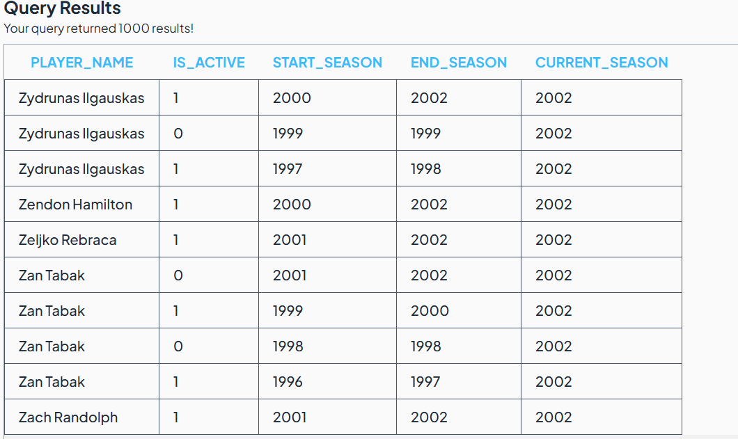

Time to load the data into our earlier schema :Prithvi.nba_player_scd

Insert into Prithvi.nba_player_scd

WITH lagged AS(

SELECT player_name,

is_active,

COALESCE(LAG(is_active,1) OVER(PARTITION BY player_name ORDER BY current_season),0) as is_active_last_season,

current_season

FROM prithvi.nba_players

),

streaked AS(

SELECT *,

SUM(CASE WHEN

is_active <> is_active_last_season THEN 1 ELSE 0 END) OVER(PARTITION BY player_name ORDER BY current_season)AS streak_identifier

FROM lagged

)

SELECT player_name,

MAX(is_active) AS is_active,

MIN(current_season) as start_season,

MAX(current_season) as end_season,

'2002' as current_season

FROM streaked

GROUP BY player_name,streak_identifier

This is the 1-time load for the scd table, now let’s look at the incremental approach.

Incremental Load thought process

Lets load the data only till the season: 2001 and incrementally load the data of the season: 2002

Editing the above full load query as follows to recreate the scenario:

Insert into Prithvi.nba_player_scd

WITH lagged AS(

SELECT player_name,

is_active,

COALESCE(LAG(is_active,1) OVER(PARTITION BY player_name ORDER BY current_season),0) as is_active_last_season,

current_season

FROM prithvi.nba_players

WHERE current_season<=2001

),

streaked AS(

SELECT *,

SUM(CASE WHEN

is_active <> is_active_last_season THEN 1 ELSE 0 END) OVER(PARTITION BY player_name ORDER BY current_season)AS streak_identifier

FROM lagged

)

SELECT player_name,

MAX(is_active) AS is_active,

MIN(current_season) as start_season,

MAX(current_season) as end_season,

'2001' as current_season

FROM streaked

GROUP BY player_name,streak_identifier

1278 rows inserted

Now the incremental logic:

WITH last_season_scd AS (

SELECT * FROM prithvi.nba_player_scd

WHERE current_season = 2001

),

current_season_scd AS (

SELECT * FROM prithvi.nba_players

WHERE current_season = 2002

)

SELECT

COALESCE(ls.player_name,cs.player_name) AS player_name ,

COALESCE(ls.start_season,cs.current_season) AS start_season,

COALESCE(ls.end_season,cs.current_season) AS end_season,

ls.is_active as is_active_last_season,

cs.is_active as is_active_this_season,

CASE WHEN ls.is_active <> cs.is_active THEN 1

WHEN ls.is_active = cs.is_active THEN 0 END AS did_change,

2002 as current_season

FROM last_season_scd ls

FULL OUTER JOIN current_season_scd cs

ON ls.player_name=cs.player_name

AND ls.end_season+1 = cs.current_season

Explanation for the above: We take the values from the last season scd, for this current season scd, we need to get the data from Prithvi.nba_players for year 2002.

* COALESCE(ls.player_name,cs.player_name) AS player_name

For the new players in season 2002, ls.player_name is null, hence it takes cs.player_name as the player_name for new players

Similarly for the start_season, end_season for the new players in 2002.

* ls.is_active as is_active_last_season

is_active flag for the last season

* cs.is_active as is_active_this_season

is_active flag for current season

* CASE WHEN ls.is_active <> cs.is_active THEN 1 WHEN ls.is_active = cs.is_active THEN 0 END AS did_change

Did_change flag to track if the is_active flag is changing from 2001 to 2002

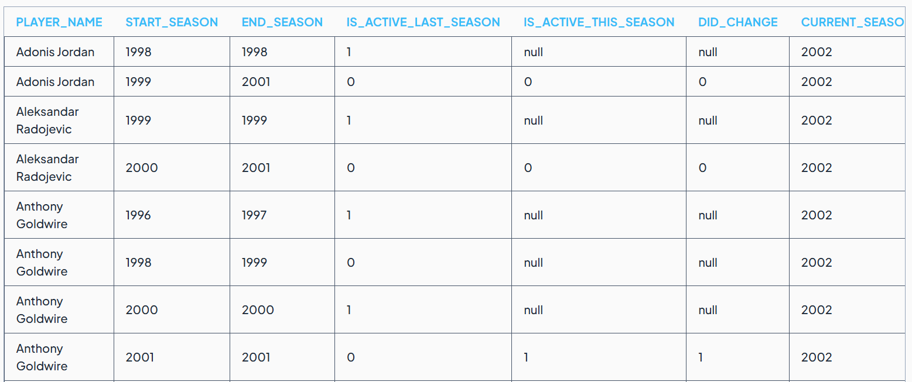

Three values for did_change flag: 1,0,NULL.

NULL happens in 2 cases:

1. For a new player

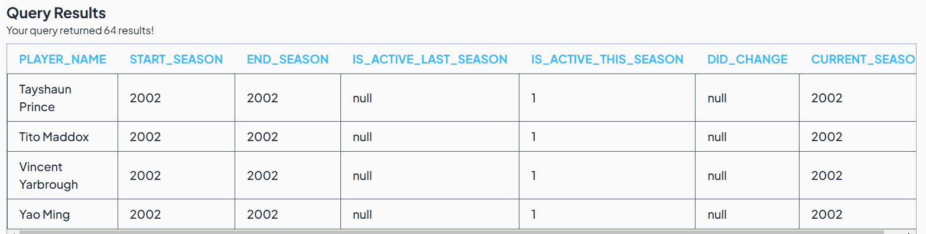

1. For old players where end_season is less than 2001. These records don’t change as it happened in the past

We will handle all the scenarios with did_change column in the next step, by adding an array element as follows:

WITH last_season_scd AS (

SELECT * FROM prithvi.nba_player_scd

WHERE current_season = 2001

),

current_season_scd AS (

SELECT * FROM prithvi.nba_players

WHERE current_season = 2002

),

combined as(

SELECT COALESCE(ls.player_name,cs.player_name) AS player_name ,

COALESCE(ls.start_season,cs.current_season) AS start_season,

COALESCE(ls.end_season,cs.current_season) AS end_season,

ls.is_active as is_active_last_season,

cs.is_active as is_active_this_season,

CASE WHEN ls.is_active <> cs.is_active THEN 1

WHEN ls.is_active = cs.is_active THEN 0 END AS did_change,

2002 as current_season

FROM last_season_scd ls

FULL OUTER JOIN current_season_scd cs

ON ls.player_name=cs.player_name

AND ls.end_season+1 = cs.current_season

)

SELECT player_name,

did_change,

CASE

WHEN did_change = 1

THEN ARRAY[ROW(is_active_last_season,start_season,end_season),ROW(is_active_this_season,current_season,current_season)]

WHEN did_change = 0

THEN ARRAY[ROW(is_active_last_season,start_season,end_season+1)]

WHEN did_change is NULL

THEN ARRAY[ROW(COALESCE(is_active_last_season,is_active_this_season),start_season,end_season)]

END

FROM combined

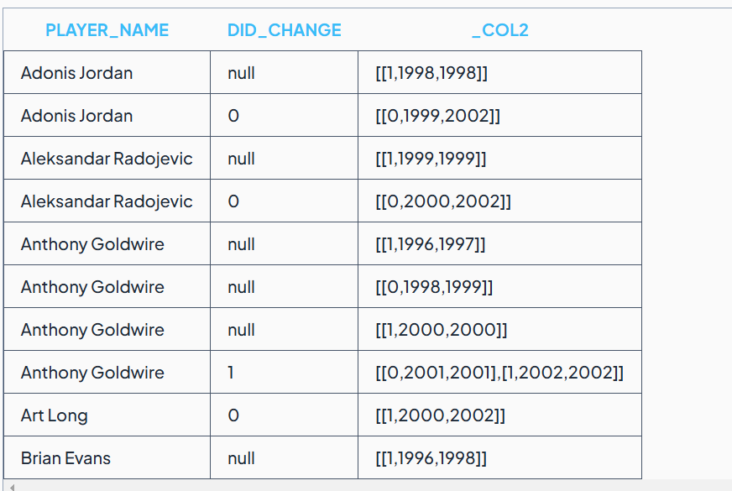

Final query:

INSERT INTO prithvi.nba_player_scd

WITH

last_season_scd AS (

SELECT

*

FROM

prithvi.nba_player_scd

WHERE

current_season = 2001

),

current_season_scd AS (

SELECT

*

FROM

prithvi.nba_players

WHERE

current_season = 2002

),

combined AS (

SELECT

COALESCE(ls.player_name, cs.player_name) AS player_name,

COALESCE(ls.start_season, cs.current_season) AS start_season,

COALESCE(ls.end_season, cs.current_season) AS end_season,

CASE

WHEN ls.is_active <> cs.is_active THEN 1

WHEN ls.is_active = cs.is_active THEN 0

END AS did_change,

ls.is_active AS is_active_last_season,

cs.is_active AS is_active_this_season,

2002 AS current_season

FROM

last_season_scd ls

FULL OUTER JOIN current_season_scd cs ON ls.player_name = cs.player_name

AND ls.end_season + 1 = cs.current_season

),

changes AS (

SELECT

player_name,

current_season,

CASE

WHEN did_change = 0 THEN ARRAY[

CAST(

ROW(

is_active_last_season,

start_season,

end_season + 1

) AS ROW(

is_active integer,

start_season integer,

end_season integer

)

)

]

WHEN did_change = 1 THEN ARRAY[

CAST(

ROW(is_active_last_season, start_season, end_season) AS ROW(

is_active integer,

start_season integer,

end_season integer

)

),

CAST(

ROW(

is_active_this_season,

current_season,

current_season

) AS ROW(

is_active integer,

start_season integer,

end_season integer

)

)

]

WHEN did_change IS NULL THEN ARRAY[

CAST(

ROW(

COALESCE(is_active_last_season, is_active_this_season),

start_season,

end_season

) AS ROW(

is_active integer,

start_season integer,

end_season integer

)

)

]

END AS change_array

FROM

combined

)

SELECT

player_name,

arr.is_active,

arr.start_season,

arr.end_season,

current_season

FROM

changes

CROSS JOIN UNNEST (change_array) AS arr